WELCOME TO IRBMANAGER

NEW USER INSTRUCTIONS:
To Login:
Go to https://cchhs.my.irbmanager.com/Login.aspx
Your email address is your user name
Your password defaults to yourlastnameirb – all one word, lower case. As an example, Betty Donoval’s password will be donovalirb.
The client name will default to CCHHS
Click Login

You will then be asked to change your password.
Once you are logged in, you will see your “Dashboard”
To complete a Protocol Submission:
On the left-side of the screen, under Actions, click “Click here to submit a new
Submission for CCHHS IRB approval”
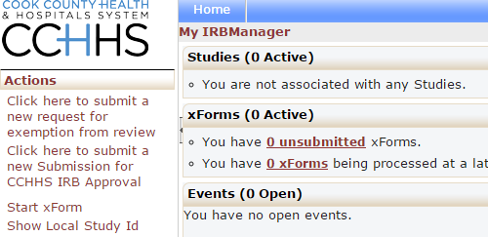
A New Submission Form will open in a new tab
Follow instructions on each page, complete the questions.

Click Next when the page is complete; or
Click Save for later if you need to leave the submission and return at a later time.

If you find that you would like to return to a page that you’ve completed, you can “jump” to the page by using the drop-down menu at the top center of the page.
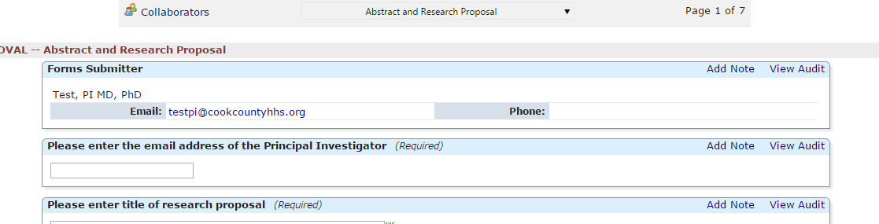
When you get to the end of the form, please click Submit

If any required fields have been left blank, you will be notified and directed to complete them.
To view the already submitted study:
In the upper left, under Actions, click “Show Local Study Id” – This is a toggle between the sponsor number and the IRB number
On the bottom of the page, under “My Studies” click the link for 2015-001-CCDPH, where you can view the study from a Researcher’s point of view
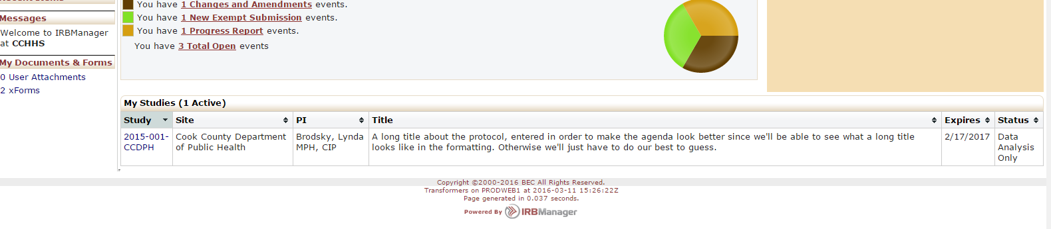
By scrolling to the bottom of the page and clicking “New Exempt Submission” you can enter the submission “Event”
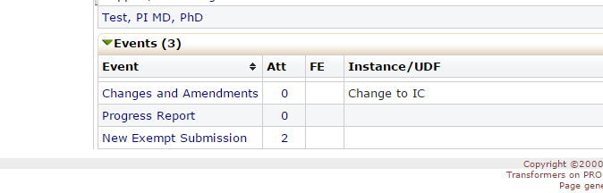
Once inside the “Event” on the left side of the screen, under “Actions” you may click xForms to view the submission
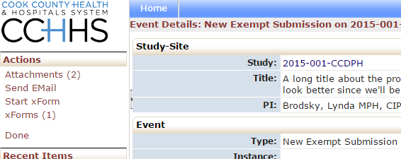
or Attachments to view the document attachments

