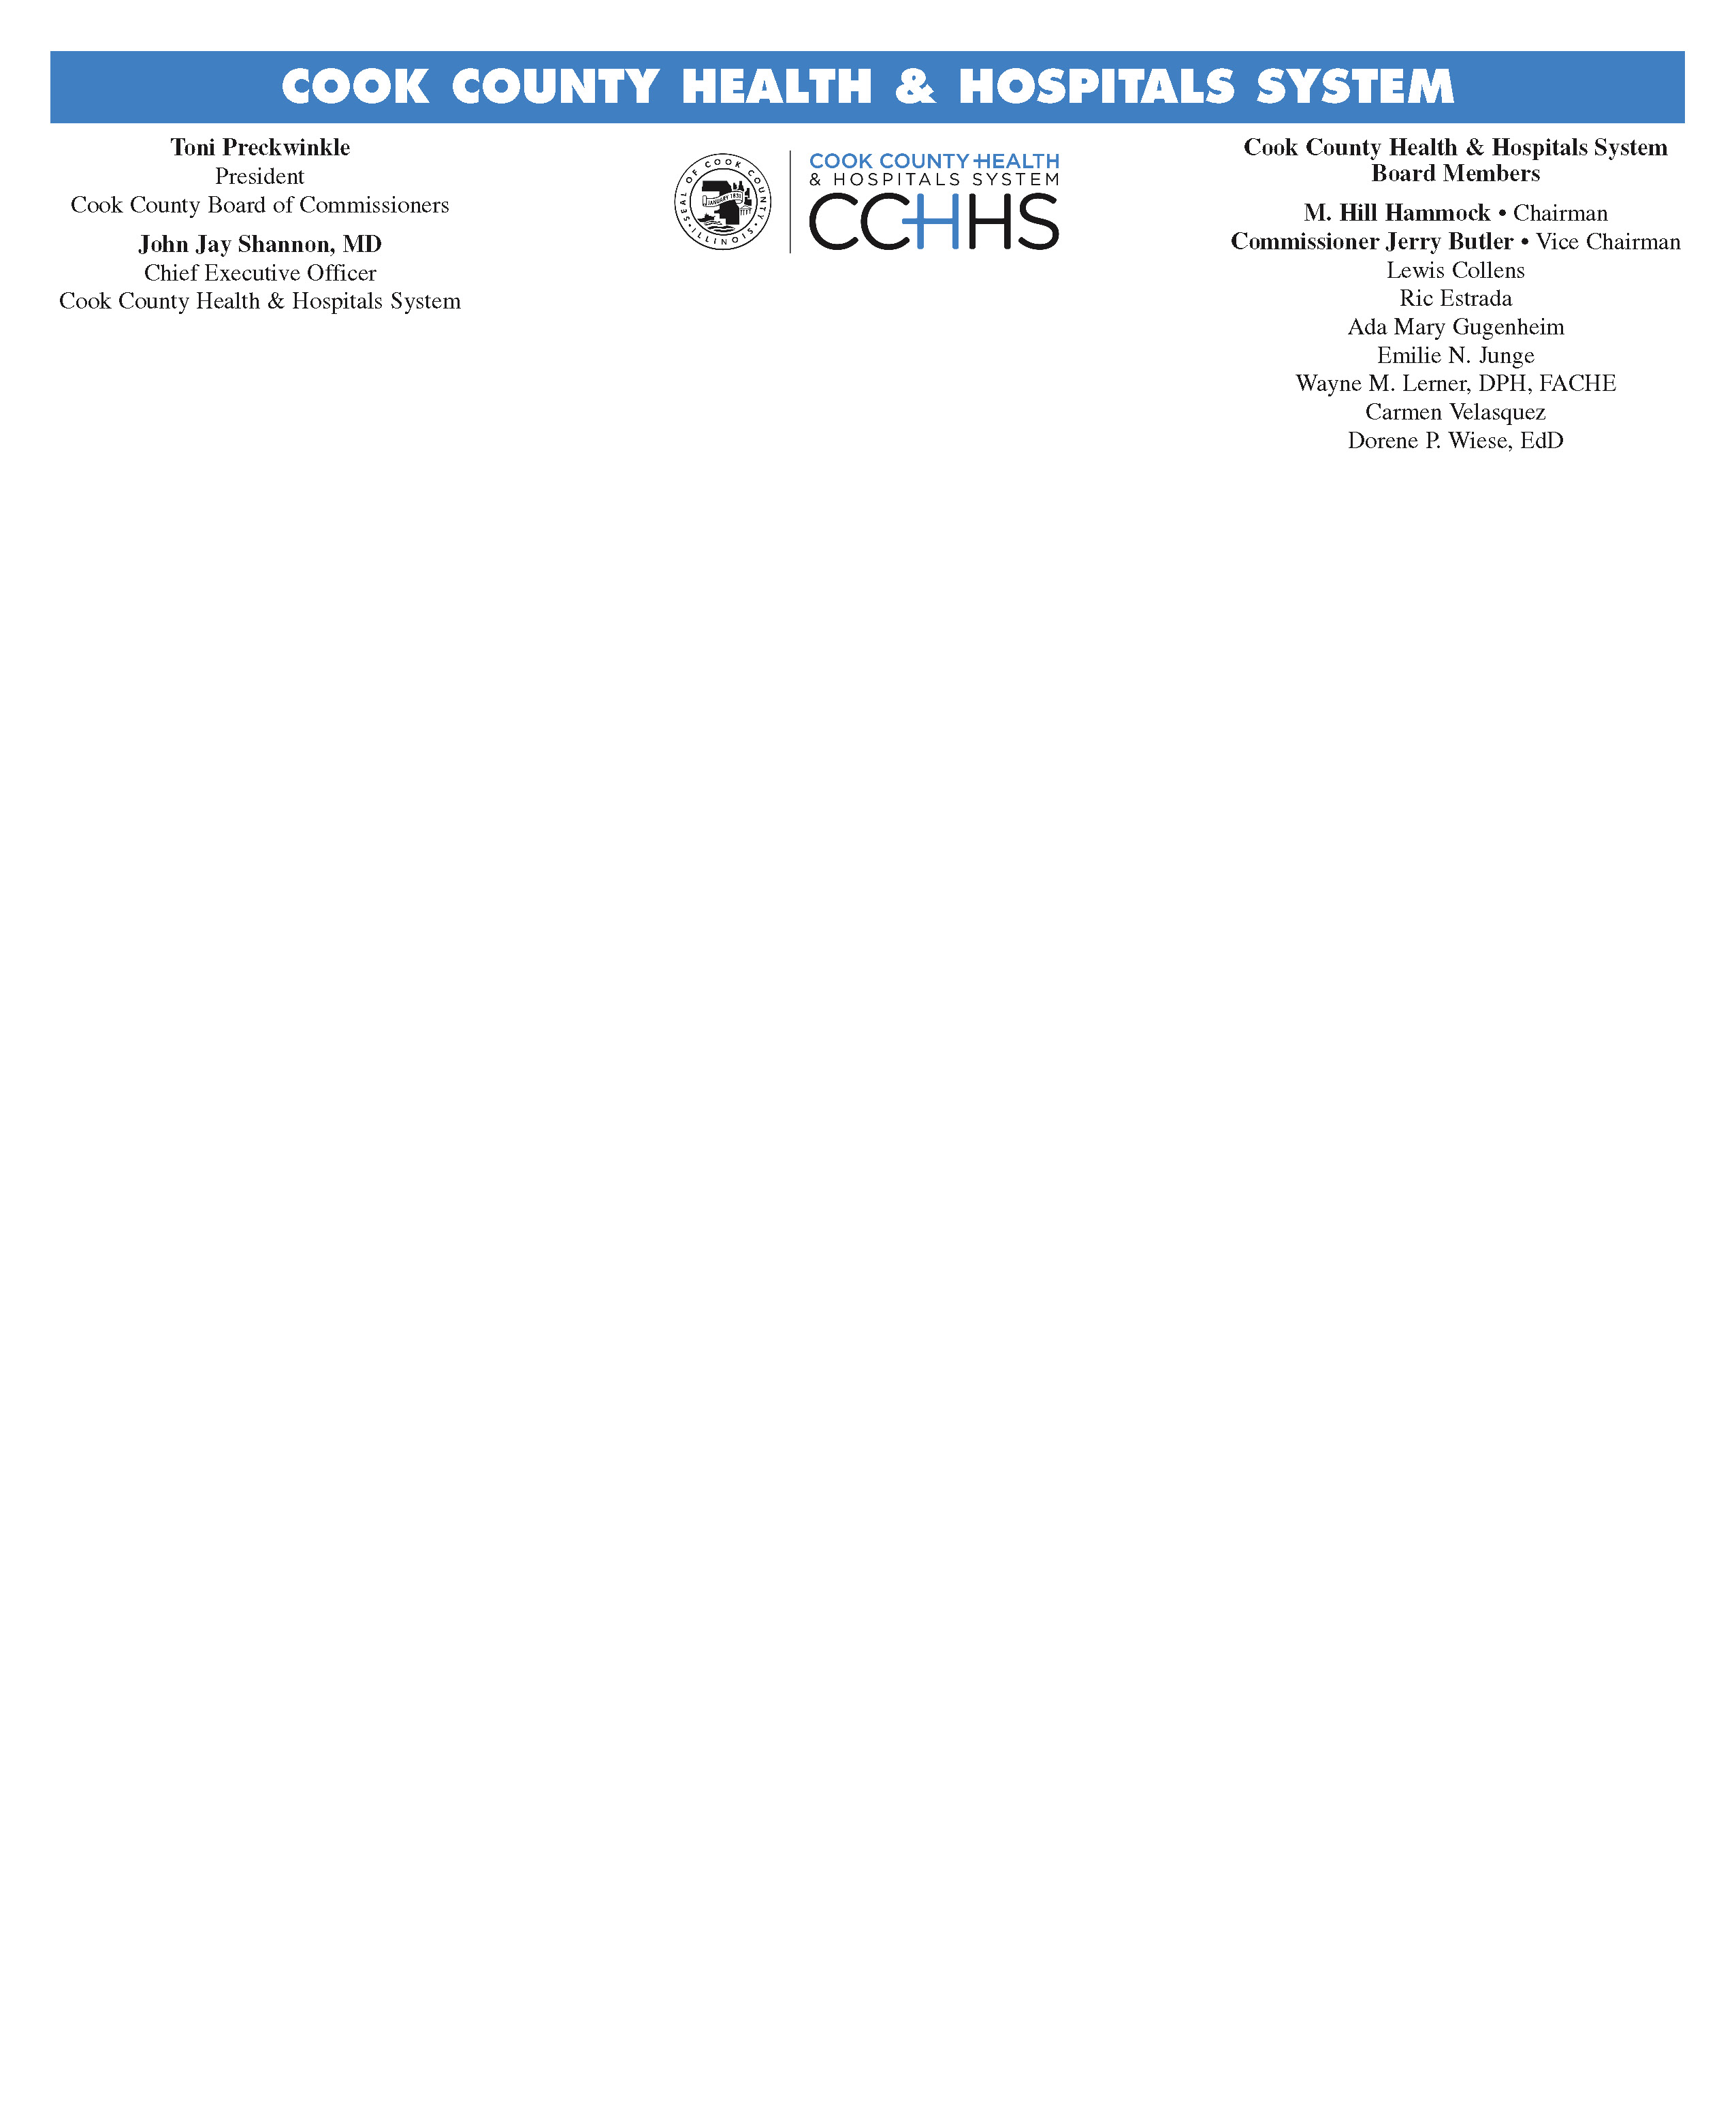

Office of Research Affairs
627 S. Wood St., Room 333
Chicago, IL 60612
(312)864-4823

Phone
Phone

Fees for Cook County Health & Hospitals System IRB Review
Issued December 1, 2015; Effective January 1, 2016

CCHHS IRB charges a review fee for industry sponsored research. IRB review fees are not charged for non-profit sponsored studies supported by the National Institutes of Health (NIH), other government agencies, or investigator-initiated studies. A onetime fee will be charged for the review of any new industry funded studies submitted on or after January 1, 2016. There will be no charge for renewals, amendments/modifications, protocol deviations, unanticipated events involving risk, or final reports.

Rates for IRB Reviews of Industry Sponsored Research (effective 1/1/16)
Type of Review | Initial | Continuing | Amendment | Closing
Full | $2,800.00 | No Charge | No Charge | No Charge
Expedited | $1,500.00 | No Charge | No Charge | No Charge
Exempt | $500.00 | No Charge | No Charge | No Charge

The fees are based on the anticipated costs associated with the protocol review by the IRB and are charged for services rendered. The fees are due in full even if the IRB does not approve the study, participants are never enrolled, or the study is terminated before objectives are reached. IRB fees are non-refundable and subject to change.

The invoicing and collection of fees will be managed by The Hektoen Institute for Medical Research with the assistance of CCHHS Office of Research Affairs. The IRB fee is to be budgeted as a separate line item in the contract budget and reimbursed by the sponsor at the time of contract execution. The study specific Hektoen fund number should be included in the IRB submission.

When a new industry sponsored study is filed with CCHHS IRB, The Hektoen Institute will be notified by Research Affairs that an invoice was sent to the Principal Investigator. Upon receipt of the invoice, the Principal Investigator will direct The Hektoen Institute to transfer money from the study’s fund to IRB account #129.

Should you have any questions or require clarification about the collection of the IRB fee, please contact Betty Donoval (bdonoval@cookcountyhhs.org) in Research Affairs at (312) 864-4821.

Should you have any questions or require clarification about transferring funds from your study fund to our IRB account, please contact Mariela Romo (marielaromo@hektoen.org) at The Hektoen Institute at (312) 768-6021.

